# **Power and data cable description**

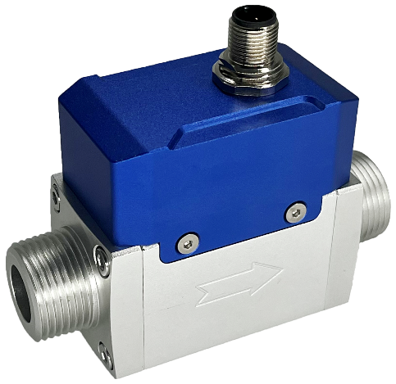

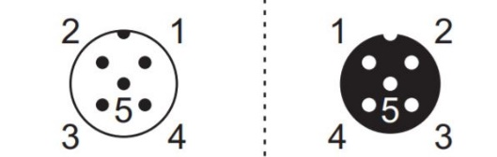Table 1: FS19HD wire (M12) assignments.

|  |  |  |
| --- | --- | --- |
| Wire | Color | Definition |
| 1 | Brown | 12 ~ 24 Vdc |
| 2 | White | RS485 B (-) |
| 3 | Blue | GND, common ground |
| 4 | Black | RS485 A (+) |
| 5 | Gray | 1 ~ 5 Vdc output |

Socket Cable

Figure 1: FS19HD socket and cable

# **RS485 Modbus communication protocol**

The digital communication protocol is based on standard Modbus RTU Half-plex mode. A master (PC or PLC) can communicate with multiple slaves (the current product) for data exchange and communication parameter configuration.

## **Hardware connection**

The hardware layer is TIA/EIA-485-A, as illustrated below. In this configuration, the product (FS19HD) is a slave.

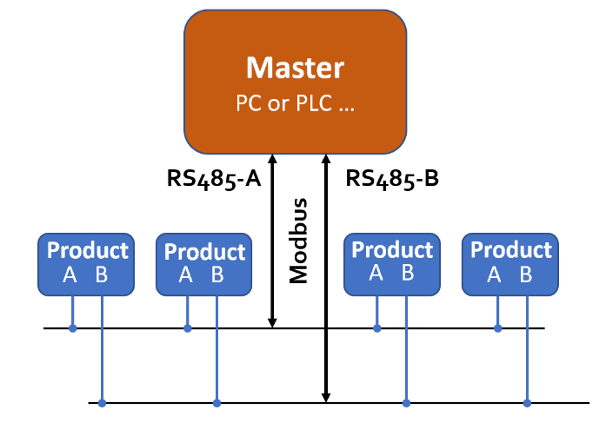

Figure 2: RS485 hardware connection

## **Communication parameters**

The PC UART communication parameters are listed in the following table.

|  |  |
| --- | --- |
| **Parameters** | **Protocol** |
| **RTU** |
| Baud rate (Bits per second) | 38400 bps |
| Start bits | 1 |
| Data bits | 8 |
| Stop bits | 1 |
| Even/Odd parity | None |
| Bits period | 104.2 µsec |
| Bytes period | 1.1458 msec |
| Maximum data length | 20 |
| Maximum nodes | 247 |

## **Frame**

The frame function is based on the standard Modbus RTU framing:

|  |  |  |  |  |  |
| --- | --- | --- | --- | --- | --- |
| **Start_bits** | **Address** | **Function codes** | **Data** | **CRC** | **Stop_bits** |
| T1-T2-T3-T4 | 8 bit | 8 bit | N 8 bit (20≥n≥0) | 16 bit | T1-T2-T3-T4 |

**Start_bits**: 4 periods bit time, for a new frame.

**Address:** The address can be set from 0 to 247 except for 157 (0x9d). 0 is the broadcast address.

**Function codes:** Define the product (FS19HD)'s functions/actions (slaves), either execution or response.

**Data:** The address of the register, length of data, and the data themselves.

**CRC:** CRC verification code. The low byte is followed by the high byte. For example, a 16-bit CRC is divided into BYTE_H and BYTE_L. In the framing, the BYTE_L will come first, then followed by the BYTE_H. The last one is the STOP signal.

**Stop_bits:** 4 periods bit time, for ending the current frame.

## **Function codes**

The Modbus function codes applied for the product are the sub-class of the standard Modbus function codes. These codes are used to set or read the registers of the product:

|  |  |  |  |
| --- | --- | --- | --- |
| Code | Name | | Functions |
| 0x03 | Read register | Int, char, float | Read register(s) |
| 0x06 | Set single register | Int, char, float | Write one single 16-bit register |
| 0x08 | CRC verification | Int | Verify the communication |
| 0x10 | Set multiple registers | Int, char, float | Write multiple registers |

## **Registers**

The product (FS19HD) has multiple registers available for the assignment of the various functions. With these functions, the user can obtain the data from the products, such as *product address* and *flow rates* from the registers, or set the product functions by writing the corresponding parameters.

The currently available registers are listed in the following table, and the registers may be customized upon contacting the manufacturer. Where R: read; W: write-only; W/R: read and write.

**Note: At the time of shipping, the write protection function is enabled except for address and baud rate. Once the user completes the register value change, the write protection will be automatically enabled once again to prevent incidental data loss.**

|  |  |  |  |
| --- | --- | --- | --- |
| Functions | Description | Register | Modbus reference |
| Address | Product address (R/W) | 0x0081 | 40130 (0x0081) |
| Serial number | Serial number of the product | 0x0030 ~ 0x0035 | 40049 (0x0030) |
| Flow rate | Current flow rate (R) | 0x003A ~ 0x003B | 40059 (0x003A) |
| Accumulated flow | Totalizer or accumulated flow rate (R) | 0x003C ~ 0x003E | 40061 (0x003C) |
| Calorific | Calorific of the gas (R) | 0x005B | 40092 (0x005B) |
| Maximum flowrate | Set maximum flowrate (R/W) | 0x0085 | 40134 (0x0085) |
| GCF_gas1 | Gas correction factor (GCF) of gas 1 (natural gas) (R/W) | 0x008B | 40140 (0x008B) |
| GCF_gas2 | Gas correction factor (GCF) of gas 2 (LPG) (R/W) | 0x0095 | 40150 (0x0095) |
| GC_air | Gas identification of air (R/W) | 0x0091 | 40146 (0x0091) |
| GC_gas | Gas identification of gas (R/W) | 0x0053 | 40084 (0x0053) |
| GC_threshold | Gas identification limit (R/W) | 0x0092 | 40147 (0x0092) |
| Write protection | Write protection of selected parameters (W) | 0x00FF | 40256 (0x00FF) |

The detailed information of each register is described below: Y: enabled; N: disabled

|  |  |  |  |
| --- | --- | --- | --- |
| **Address** | **0x0081** | **Write** | Y |
| **Read** | Y |
| **Description** | Address of the product | | |
| **Value type** | UINT 16 | | |
| **Notes** | Values from 1 to 247 except for 157 (0x9d). Broadcast address 0 is not enabled, the default address is 1. | | |

|  |  |  |  |
| --- | --- | --- | --- |
| **Serial number, SN** | **0x0030 ~ 0x0035** | **Write** | N |
| **Read** | Y |
| **Description** | Series Number of the product, SN | | |
| **Value type** | UINT 8 (12bits) | | |
| **Notes** | SN= value(0x0030), value(0x0031),….,value (0x0035);  Receiving 12 bytes as: 2A 47 37 41 45 49 30 32 30 35 38 2A , the corresponding Serial Number is *\*G7AEI02058\**. | | |

|  |  |  |  |
| --- | --- | --- | --- |
| **Flow rate** | **0x003A ~ 0x003B** | **Write** | N |
| **Read** | Y |
| **Description** | Current flow rate | | |
| **Value type** | UINT 16 | | |
| **Notes** | Flow rate = [Value (0x003A)*65536 + value (ox003B)]/1000  e.g.: for a flow rate of 123.456 SCFH, the user will read “1 (0x0002)” from register 0x003A and “57920 (0xE240)” from register 0x003B, therefore  Current flow rate = (1*65536+57920)/1000 = 123.456 SCFH | | |

|  |  |  |  |
| --- | --- | --- | --- |
| **Accumulated flow** | **0x003C ~ 0x003E** | **Write** | Y |
| **Read** | Y |
| **Description** | Accumulated or totalized flow rate | | |
| **Value type** | UINT 32 + UNIT 16 | | |
| **Notes** | Totalizer or accumulated flow rate  = Value (0x003C) * 65536 + Value (0x003D) + Value (0x003E)/1000  **e.g.,**  For an accumulated flow rate of 3452.245 m3, the user will read “0 (0x0000)” from register 0x003C; “3452 (0x0D7C)” from register 0x003D, and “245 (0x00F5)” from register 0x003E.  Then, the accumulated flow rate = 0 + 3425 + 245/1000 = 3425.245. | | |

|  |  |  |  |
| --- | --- | --- | --- |
| **Calorific** | **0x005B** | **Write** | N |
| **Read** | Y |
| **Description** | The calorific of the gas | | |
| **Value type** | UINT 16 | | |
| **Notes** |  | | |

|  |  |  |  |
| --- | --- | --- | --- |
| **Maximum flowrate** | **0x0085 ~ 0x0086** | **Write** | Y |
| **Read** | Y |
| **Description** | Set the maximum flow rate limit | | |
| **Value type** | UINT 16 | | |
| **Notes** | Maximum flow rate limit =(Value(oxoo85)*65536+Vlaue(0x0086))/1000  e.g., to set a maximum flow rate limit of 30 SCFH, write o to register 0x0085, and write 30000 to register 0x0086. Then the value will be  (0*65536+30000)/1000 = 30 SCFH | | |

|  |  |  |  |
| --- | --- | --- | --- |
| **GCF_gas1** | **0x008B** | **Write** | Y |
| **Read** | Y |
| **Description** | The gas conversion factor for gas 1 (natural gas). | | |
| **Value type** | UINT 16 | | |
| **Notes** | The GCF of gas 1 (natural gas), default value is 1035. | | |
| **GCF_gas2** | **0x0095** | **Write** | Y |
| **Read** | Y |
| **Description** | The gas conversion factor for gas 2 (LPG). | | |
| **Value type** | UINT 16 | | |
| **Notes** | The GCF of gas 2 (LPG), default value is 286. | | |

|  |  |  |  |
| --- | --- | --- | --- |
| **GC_air** | **0x0091** | **Write** | Y |
| **Read** | Y |
| **Description** | This value is the gas ID for air | | |
| **Value type** | UINT 16 | | |
| **Notes** | The default value is 32768±200.  This value may be dependent on the actual offset value of the meter. | | |

|  |  |  |  |
| --- | --- | --- | --- |
| **GC_gas** | **0x0053** | **Write** | Y |
| **Read** | Y |
| **Description** | This value is assigned for specific gases at the time of order | | |
| **Value type** | UINT 16 | | |
| **Notes** | The default value for methane or natural gas is 35800±200, and for LPG is 29200±200.  The meter can automatically switch the calibration between air (calibrated gas) and gas 1 (natural gas) or gas2 (LPG). | | |

|  |  |  |  |
| --- | --- | --- | --- |
| **GC_threshold** | **0x0092** | **Write** | Y |
| **Read** | Y |
| **Description** | Set a limit for the gas switch | | |
| **Value type** | UINT 16 | | |
| **Notes** | The default value is 1000, and the maximum of 10000.  If the GC_threshold is set to 10000, this function will be disabled.  For example:  If GC_gas≥GC_air+GC_threshold, the gas will be gas 1 (natural gas), Flowrate_gas1 (natural) = flowrate_air*GCF_gas1/1000,  and the “GAS” symbol will be displayed on the LCD, replacing the meter address value.  Or GC_gas≤ GC_air-GC_threshold, the gas will be gas 2 (LPG),  Flowrate_gas2 (LPG) = flowrate_air*GCF_gas2/1000,  and the “GAS” symbol will be displayed on the LCD, replacing the meter address value. | | |

|  |  |  |  |
| --- | --- | --- | --- |
| **Write protection** | **0x00FF** | **Write** | Y |
| **Read** | N |
| **Description** | Write protection disabler for a set value to a specific register. | | |
| **Value type** | Unsigned int, Fixed value 0xAA55 | | |
| **Notes** | This function is enabled at the time of product shipment. To enable the write function of a specific parameter, such as GCF, the user needs to send 0xAA55 to the register 0x00FF, and then the write function will be enabled (write protection is disabled). After the write execution is completed, the firmware will automatically re-enable the write protection.  **Only Address will not be write-protected.** | | |